MARKAZ UNANI MEDICAL COLLEGE & HOSPITAL
PUTHUPPADI, KOZHIKODE, KERALA- 673586.
DETAILS OF TEACHING FACULTY-2025

Sl. No |  |  | Name of the Teacher | Date of Birth |  |  | Date of Joining |  | UG Qualification (University) | PG Qualification with Subject (University) |  | Ph.D (Qualification with Subject (University) | Department |  |  | Designation | Mobile Number | State Board Registration No. |  |  | Email Address | Photograph
1. | Prof. Shaik Shahul Hameed |  |  | 01/06/1960 |  |  | 16/12/2019 |  | B.U.M.S.  (S.V. University) | (M.D.) Ilmul Advia  (Osmania University) |  | N/A | Ilmul Saidla |  |  | Principal & Superintendent | 9840454821 | 127 |  |  | drshaiksha60@gmail.com | 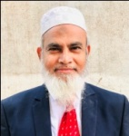
KULLIYAT
2. | Dr. Ansari Abdul Waqas Abdul Karim |  |  | 04/08/1988 |  |  | 20/12/2023 |  | B.U.M.S.  (Maharashtra University of Health Sciences) | M.D.  Kulliyat  (Rajiv Gandhi University of Health Sciences) |  | N/A |  | Kulliyat |  | Associate Professor | 9987555011 | I-76781-D |  |  | waqas.ayesha16@gmail.com | 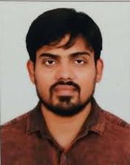
3. | Dr. Saima.T |  |  | 02/11/1996 |  |  | 19/02/2024 |  | B.U.M.S.  (The Tamil Nadu Dr. MGR Medical University) | M.D.  Kulliyat  (Rajiv Gandhi University of Health Sciences) |  | N/A |  | Kulliyat |  | Assistant Professor | 7418836540 | 0546 |  |  | saimat.vnb@gmail.com | 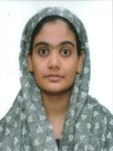
4. | Mr. M.D. Nadim Akhter |  |  | 01/01/1990 |  |  | 21/06/2016 |  | (B.A.) Urdu Languag, Sociology & Islamic Studies (Maulana Azad National University ) | M.A. Arabic (Maulana Azad National University ) |  | N/A |  | Arabic |  | Assistant Professor | 7907163516 | N/A |  |  | ndmmunna@gmail.com | 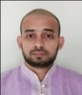
5. | Mr. Muhammed P. M. |  |  | 07/11/1983 |  |  | 14/05/2018 |  | B.A. Arabic (Markazu Ssaquafathi Ssunniyya, Kozhikode, Kerala) | M.A. Arabic (Aligarh Muslim University, Aligarh) |  | Ph. D, Arabic Literature (Jawaharlal Nehru University) |  | Arabic |  | Assistant Professor | 9048748312 | N/A |  |  | muhammedkvm@gmail.com | 
 | TASHREEHUL BADAN
6. | Prof. Mohammad Unwan |  |  | 17/04/1969 |  |  | 05/08/2019 |  | B.U.M.S.  ( Delhi University) | N/A |  | N/A | Tashreehul Badan |  |  | Professor | 9645887545 | 101 |  |  | unwan1969@gmail.com | 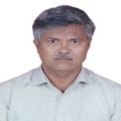
7. | Dr. Aatera Anees Ahmad |  |  | 07/07/1987 |  |  | 14/12/2018 |  | B.U.M.S.  (Maharashtra University of Health Sciences | N/A |  | N/A | Tashreehul Badan |  |  | Associate Professor | 7767075145 | I-68761-D |  |  | draatera87@gmail.com | 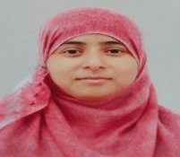
MUNAFE UL AZA
8. |  |  | Dr. Athar Iqbal | 07/07/1966 |  |  | 12/4/2021 |  | B.U.M.S.  (University of Delhi) | N/A |  | N/A | Munafe ul Aza |  |  | Professor | 9936679066 | 004264 |  |  | hakkimathar.iqbal@yahoo.com | 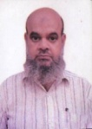
MAHIYATUL AMRAZ
9. |  | Dr. Nazma Mubin |  |  |  | 02/06/1971 | 09/04/2021 |  | B.U.M.S.  (Aligarh Muslim University) | N/A |  | N/A | Mahiyathul Amraz |  |  | Professor | 9380304940 | 003161 |  |  | nazmamubin2017@gmail.com | 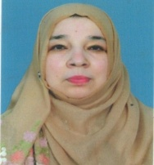
10. |  | Dr. Farukh Hasan |  |  |  | 10/04/1994 | 20/02/2024 |  | B.U.M.S.  (Jamia Hamdrad, Hamdrad University) | M.D.  Mahiyatul Amraz  (Rajiv Gandhi University of Health Sciences) |  | N/A | Mahiyatul Amraz |  |  | Assistant Professor | 8287828879 | DBCP/U/9438 |  |  | farukhhasan94@gmail.com | 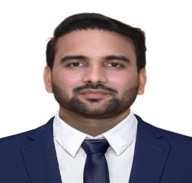
TAHAFFUZI WA SAMAJI TIB
11. |  | Dr .P. Nazia Farheen |  |  |  | 24/08/1980 | 25/09/2021 |  | B.U.M.S (N.T.R. University of HS) | M.D. Thahaffuzi Wa Samaji Tib (Maharashtra University of Health Sciences) |  | N/A | Thahaffuzi Wa Samaji Tib |  |  | Professor | 7981065264 | 146 |  | pnaziafarheen@gmail.com |  |  | 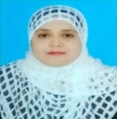
12. |  | Dr. Shabnam |  |  |  | 01/07/1989 | 14/01/2019 |  | B.U.M.S.  (University of Delhi) | M.D.  (Rajiv Gandhi University of Health Sciences) |  | N/A | Tahaffuzi wa Samaji Tib |  |  | Associate Professor | 9535760898 | DBCP/U/8174 |  | choudharyshabnam140@gmail.com |  |  | 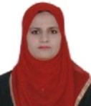
13. |  | Dr. V. Zahida Banu |  |  |  | 01/07/1989 | 23/04/2021 |  | B.U.M.S.  (N.T.R. University of HS) | M.D.  (N.T.R. University of HS) |  | N/A | Tahaffuzi wa Samaji Tib |  |  | Assistant Professor | 8919243288 | 286/U/2012 |  | zahidasyed89@gmail.com |  |  | 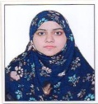
14. |  | Dr.  Usman P. M |  |  |  | 12/06/1991 | 01/08/2023 |  | B.U.M.S ( Rajiv Gandhi Institute of Health Sciences, Bangalore) | Master of Public Health (Manasarovar Global University, Madhya Pradesh) |  | N/A | Tahaffuzi wa Samaji Tib |  |  | Assistant Professor | 9744990022 | 61 |  | drusmanunani@gmail.com |  |  | 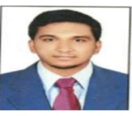
ILMUL ADVIA
15. |  | Dr. Zahoourulla |  |  |  | 15/5/1962 |  | 20/09/2023 | B.U.M.S  (University of Madras), Chennai | M.D  Ilmul Advia  (N.T.R. University of HS) |  | N/A | lmul Advia |  |  | Professor | 9384729247 | 0143 |  |  | drzahoorunani@gmail.com | 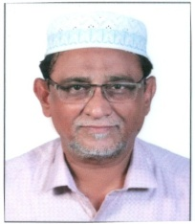
16. |  | Dr. Abdur Rasheed |  |  |  | 30/10/1985 |  | 18/04/2024 | B.U.M.S.  (Aligarh Muslim University) | M.D.  Ilmul Advia  (Rajiv Gandhi University of Health Sciences) |  | N/A | Ilmul Advia |  |  | Assistant Professor | 8318837239 | 17368 |  |  | rasheedaktc@gmail.com | 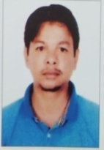
17. |  | Dr. Sadaf Joweria |  |  |  | 04/02/1993 |  | 13/09/2024 | B.U.M.S. (Barakathullah Vishwavidhyalaya) | (M. D. )Kaloji Narayana Rao University of Health Sciences, Ilmul Advia |  | N/A | Ilmul Advia |  |  | Assistant Professor | 7417637650 | 57271 |  |  | ^{sadafansari74j@gmail.com} | 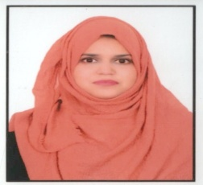
ILMUL ATFAL
18. |  | Dr. Asia Farheen |  |  |  | 07/02/1981 |  | 09/03/2022 | B.U.M.S.  (N.T.R. University of HS) | Mahir-E-Tib B.U.M.S.  (N.T.R. University of HS) | Ph.D, Ilmul - Qabalat – O – Amraz – E – Niswan (Dr. Ntr University Of Health Sciences, Vijayawada, Andhra Pradesh) |  |  |  | Qabalat wa Amraze Niswan | Associate Professor | 9000236639 | 21972 |  |  | info2dr.asiya@gmail.com | 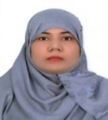
19.. |  | Dr. Umme Sana Khair |  |  |  | 25/08/1988 |  | 06/02/2021 | B.U.M.S.  (N.T.R. University of HS) | M.D.  (N.T.R. University of HS) | N/A |  |  |  | Munafe ul Aza | Associate Professor | 8106786933 | 294/U/2012 |  |  | drummesana@gmail.com | 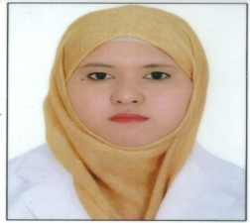
ILAJ BIT TADBEER
20. |  | Dr. Mujeeb U. |  |  |  | 31/08/1980 |  | 05/12/2017 | B.U.M.S  .(Rajiv Gandhi University of Health Sciences | M.D.  (Maharashtra University of Health Sciences) |  | N/A | Moalajat |  |  | Professor | 9446734186 | 13 |  |  | dr.u.mujeebmd@gmail.com | 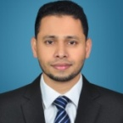
21. |  | Dr. Saif Ali Siddiqi |  |  |  | 05/01/1995 |  | 01/11/2023 | B.U.M.S.  (Aligarh Muslim University) | M.D  Ilaj bit Tadbeer  (Aligarh Muslim University) |  | N/A | Ilaj bit Tadbeer |  |  | Assistant Professor | 7668577414 | 19544 |  |  | saifalig254@gmail.com | 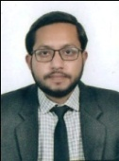
MOALAJAT
22. |  | Dr. Shaikh Mohammed Ishaque Abdul Hamid |  |  |  | 20/03/1986 |  | 21/04/2021 | B.U.M.S.  (Maharashtra University of Health Sciences) | M.D.  (Maharashtra University of Health Sciences) |  | N/A | Moalajat |  |  | Associate Professor | 9420923164 | I-63106-D |  |  | isakphd@gmail.com | 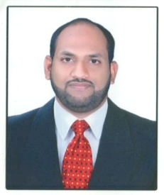
23. |  | Dr. Muhammad Ruman Khan |  |  |  | 30/06/1988 |  | 11/07/2022 | B.U.M.S.  (Aligarh Muslim University) | M.D.  (Rajiv Gandhi University of Health Sciences |  | N/A | Moalajat |  |  | Assistant Professor | 9450090387 | 15041 |  |  | dr.ruman190@gmail.com | 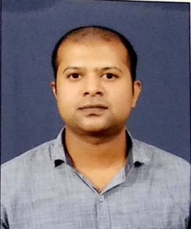
24. |  | Dr. Sajitha K. V |  |  |  | 05/03/1987 |  | 17/05/2024 | B.U.M.S  (Rajiv Gandhi University of Health Sciences) | M.D  Moalajat  (Rajiv Gandhi University of Health Sciences) |  | N/A | Moalajat |  |  | Assistant Professor | 9739629116 | 31 |  |  | sajida.shijas.m@gmail.com | 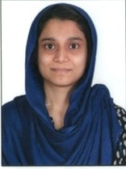
AMRAZE JILD WA TAZEENIYAT

25. |  | Dr. Shahul Hameed Areekkadan Padikkathodika |  |  |  | 10/11/1982 | 17/06/2013 |  | B.U.M.S( Rajiv Gandhi Institute of Health Sciences, Bangalore) | N/A |  | N/A | Amraze Jild wa Tazeeniyat |  |  | Professor | 9947809460 | 11 |  |  | drapshahul@gmail.com | 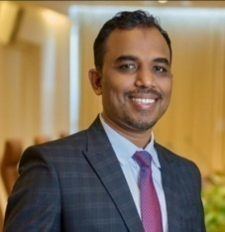
26. |  | Dr. Umai Sumaiya Banu |  |  |  | 30/07/1996 | 21/11/2024 |  | B.U.M.S ( Rajiv Gandhi Institute of Health Sciences, Bangalore) | M. D Amraze Jild wa Tazeeniyat ( Rajiv Gandhi Institute of Health Sciences, Bangalore) |  | N/A | Amraze Jild wa Tazeeniyat |  |  | Assistant Professor | 8892668267 | 2494 |  |  | umai.sumaiya@gmail.com | 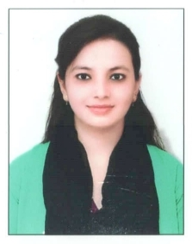
NISWAN WA QABALAT
27. |  | Dr. Salma Bano |  |  | 12/01/1961 |  | 13/12/2022 |  | B.U.M.S.  (Bangalore University) | M.D  Niswan wa Qabalat  Rajiv Gandhi University of Health and Sciences |  | N/A | Niswan wa Qabalat |  |  | Professor | 9845469885 |  | 2208 |  | sbano4@gmail.com | 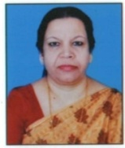
28. |  | Dr. K. Farheen Fathima |  |  | 05/01/1989 |  | 19/02/2025 |  | B.U.M.S  (DR. N.T.R University of Health Sciences  Andhra Pradesh) | Niswan wa Qabalat  (Kaloji Narayana Rao University of Health Sciences, Telangana) |  | N/A | Niswan wa Qabalat |  |  | Assistant Professor | 9515714818 |  | 270/U/2012 |  | k.farheenfathima@gmail.com | 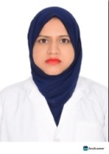
ILMUL JARAHAT
29. |  | Dr. Syed Mumshad  Ahammed |  | 15/06/1986 |  |  | 31/01/2019 |  | B.U.M.S  .(Rajiv Gandhi University of Health Sciences | N/A |  | N/A | Ilmul Jarahat |  |  | Professor | 8606841119 |  | 39 |  | drsyedmumshad@gmail.com | 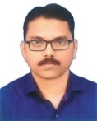
30. |  | Dr. Mohamed Abdurahiman O. K. |  | 01/12/1985 |  |  | 17/06/2013 |  | B.U.M.S.(Rajiv Gandhi University of Health Sciences) | N/A |  | N/A | Ilmul Jarahat |  |  | Professor | 9388909091 |  | 29 |  | abdurahimanok789@gmail.com | 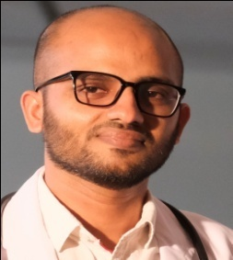
AIN-UZN-ANF-HALAQ WA ASNAN
31. | Dr. Mohammed Abdul Quadeer |  |  | 25/04/1979 |  |  | 16/03/2020 |  | B.U.M.S.  (N.T.R. University of HS) | M. D. Moalajat  (N.T.R. University of HS) |  | N/A | Ain-Uzn-Anf-Halaq wa Asnan |  |  | Professor | 9440724146 |  | 1063 |  | quadeer1@gmail.com | 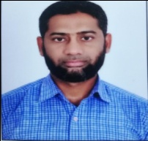
32. | Dr. Rabia Khan |  |  | 07/11/1994 |  |  | 21/10/2024 |  | B.U.M.S.  ( Jamia Hamdard University, New Delhi ) | M.D Moalajat ( Jamia Hamdard University, New Delhi ) |  | N/A | Ain-Uzn-Anf-Halaq wa Asnan |  |  | Assistant  Professor | 8447506978 |  | DBCP/U/8990 |  | rabikhan.rk1195@gmail.com | 